

**LA GRANDEE INTERNATIONAL COLLEGE**

**Simalchaur, Pokhara, Nepal**

A Project Proposal/Report

on

**Online Book Store Management System**

**Submitted to**

La Grandee International College

Bachelor of Computer Application (BCA) Program

In partial fulfillment of the requirements for the degree of Program Name under

Pokhara University

**Submitted by**

|  |  |  |  |
| --- | --- | --- | --- |
| **Name:** | **Course** | **Semester** | **P.U. Registration Number** |
| Bishal Adhikari | BCA | 6th | 2021-1-53-0348 |
| Deepak Chhantyal | BCA | 6th | 2021-1-53-0349 |
| Roshan Adhikari | BCA | 6th | 2021-1-53-0363 |
|  |  |  |  |

**Date: October 2024**

# Table of Contents

Introduction 1

Problem Statement 2

Objectives 3

Background Study 4

Methodology 5

Project Gantt Chart 6

Deliverables 7

References 8

# Table of Figures

Figure 5.1: Spiral Model 5

Figure 6.1: Project Gantt Chart 6

# Introduction

Pustak Sanjal(Online Book Store Management System) is an online store where you can easily find and buy the books you love without ever leaving your home.

We will create Pustak Sanjal because we know how hard it can be to find the books you want, especially if you don't have access to a bookstore nearby

With Pustak Sanjal you can browse through a wide selection of books from various genres, and have them delivered straight to you. Our goal is to make buying books as simple and convenient as possible. Whether you're a passionate reader or just looking for something new to read, Pustak Sanjal has something for everyone. From bestselling novels to educational textbooks, we've got a diverse collection to cater to all tastes and interests. We've design Pustak Sanjal to be user-friendly, so you can easily search for books, read reviews, and make purchases with just a few clicks. And with secure payment options and reliable delivery services, you can trust that your book will arrive safely and on time. At Pustak Sanjal, we're dedicate to providing you with the best book-buying experience possible. That's why we're always adding new titles and features to our website, so you can discover and enjoy the latest reads with ease. This project provides a user-friendly platform that enables customers to purchase books online.

The Pustak Sanjal Project was initiate in response to the growing shift in consumer behavior towards online shopping. Educational sector requires easy communication between author and reader.

Need of dedicated platform. The project aims to contribute to the digital transformation of the literary community by fostering connections among readers and promoting a shared love for books in the online space. The background of the project is rooted in adapting to the changing landscape of retail and reading habits.

# Problem Statement

As the consumer is going e-commerce, there may rise in the sale of book online. There also problems arise on the traditional bookstore. There some problems face by existing book selling system either offline or online.

1. Complicated User Interfaces: Many online bookstores lack straightforward, user-friendly designs, making it difficult for users to browse and buy books easily.

2. Inadequate Payment Security: Secure payment options, leading to concerns over transaction safety.

3. Limited Navigation and Browsing Tools: Users face difficulties when exploring large book collections due to a lack of advanced navigation features and dynamic browsing capabilities.

4. Insufficient Book Details: Many platforms fail to provide comprehensive book information such as images, pricing, and descriptions, making it harder for users to make purchasing decisions.

# Objectives

* To make user-friendly online platform where customers can shop book of their choice on their comfort.
* To increase the bookstore’s customer base by providing wide variety of books to the readers.

# Background Study

The internet has been favored by more and more people for its high efficiency and richness, and e-commerce has emerged. The online bookstore is a form of e-commerce and book sales industry in one form, it has many advantages such as: Bookstore size is relatively small, cost savings, transaction activities can be anytime, anywhere, improve service efficiency. With more people embracing the convenience of browsing and purchasing products online, there arose a clear need for an efficient and user-friendly platform specifically tailored for buying books.

The information is complete, more convenient retrieval, the new book information on the new, consumers can see in a timely manner, trading activities can be launched immediately, so online bookstore in today’s era of development is extremely rapid. Online bookstore system is the main function is that it provides platform for the consumer connect to online bookstore through internet and check the book information.

Our project’s primary goal is to leverage technology to simplify book-buying process. We aim to make discovering and purchasing books effortless and enjoyable for users of all technological proficiencies. Additionally, “Pustak Sanjal” seeks to contribute to the digital transformation of the literary community by fostering communications among readers.

In summary, the background of “Pustak Sanjal” is rooted in adapting to the changing landscape of retails book sales. Our project endeavors to make books more accessible and inclusive in the digital age, which also fostering a sense of community and connection among readers online.

# Methodology

On the development of the Pustak Sanjal system, we use the Spiral Model Approach which is the combination of the waterfall model and the iterative model.

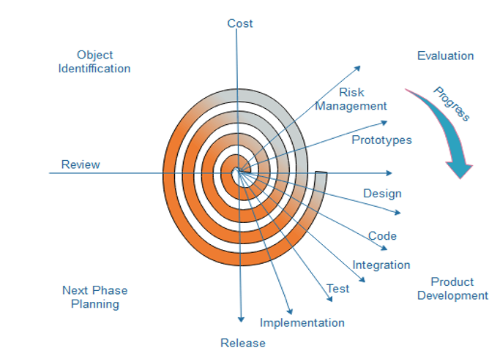

Figure 5.1: Spiral Model

Each phase of the spiral model is divided into four quadrants as shown in the above figure. These are implemented in our system on following basis.

* Object Identification: On this phase, we conduct feasibility study to understand about the Pustak Sanjal. Gather requirements and Identify Objectives of the online bookstore.
* Evaluation: On this phase, we identify potential risks which are associated with various modules like payment gateways, database handling and site traffic and evaluate them using risk mitigation strategies.
* Product Development: During this phase, we develop a prototype, different components (User login, shopping card, add/ remove items.) and test them, then address risk based on test results.
* Next phase planning: Evaluate the current progress whether it’s met the initial objectives. Plan the next set of features.

# Project Gantt Chart

Using Spiral model in the project involves iterative cycles that allows continuous refinement and risk management. When the iterative cycle progress, requirements, risk, design are refine which involves on the adding the new features on the system.

Figure 6.1: Project Gantt Chart

# Deliverables

After the system is constructed, there certain expectations to be fulfill in order to be a successful system. Some major requirements of employee’s are fulfilled and listed below:

* **Fully Functional Online Bookstore**: A complete e-commerce platform that allows users to browse, search, and purchase books seamlessly.
* **Documentation**: Intuitive and responsive design that enhances user experience across various devices, including desktops, tablets, and smartphones.
* **Secure Payment Gateway**: Integration of reliable payment processing solutions to ensure safe and efficient transactions for users.
* **Comprehensive Book Listings**: Detailed pages for each book, including images, prices, descriptions, and user reviews to assist in the decision-making process.

# References

tutorialspoint. (2019). *SDLC Spiral Model*. Www.tutorialspoint.com. https://www.tutorialspoint.com/sdlc/sdlc_spiral_model.htm

Nirvaya. (2021). *Grey.com.np*. Grey.com.np. <https://www.grey.com.np>

Acharya, K. (2020, February 10). *ONLINE BOOK STORE MANAGEMENT SYSTEM PROJECT REPORT.* ResearchGate; unknown. https://www.researchgate.net/publication/380729587_ONLINE_BOOK_STORE_MANAGEMENT_SYSTEM_PROJECT_REPORT